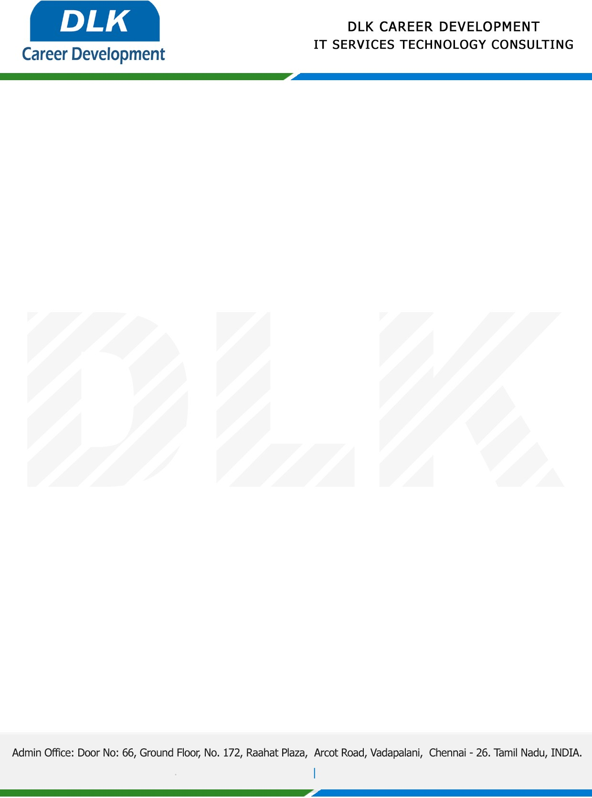

**Date: 23/ May/2023**

**SUB: PROJECT COMPLETION CERTIFICATE**

This is to certify that **MS SHAKTHI PRIYA T (REG NO:** **832100622) MSC- Computer Science,** final year student **Shri Krishnaswamy College for Women, Chennai** has Successfully Completed the Project Work under the domain of “**Python”** in our organization during the Period **(December 2022 to May 2023).**

**Topic:** Object Detection Using Yolo Concept in Deep Learning

We appreciate your interest in **DLK CAREER DEVELOPMENT**

**“Best Wishes for Your Future Endeavors “**

For **DLK CAREER DEVELOPMENT**

**HR Manager**

**VELMURUGAN J**